LC#24 SWAP NODE IN PAIRS
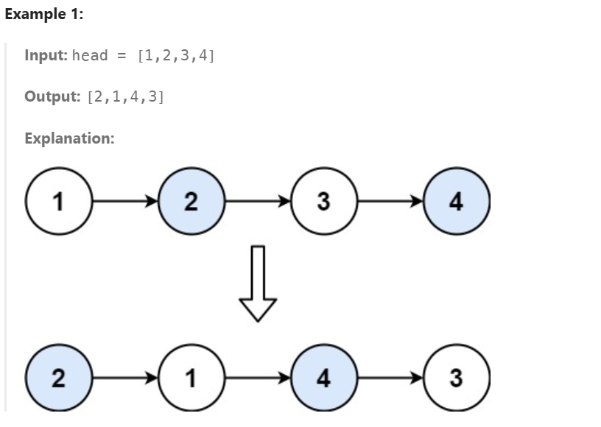
APP:
->no reversal required just normal swap take two node and swap them
class Solution {
public ListNode swapPairs(ListNode head) {
ListNode dummy = new ListNode(0);
dummy.next = head;
ListNode prev = dummy;
while(prev.next!=null && prev.next.next!=null)
{
ListNode first = prev.next;
ListNode second = first.next;
//swapping
first.next = second.next;
second.next = first;
prev.next = second; // assigning to the starting(reversal)
prev = first;//as it is shifted right
}
return dummy.next;}}
#LC61 ROTATE LIST BY K PLACES
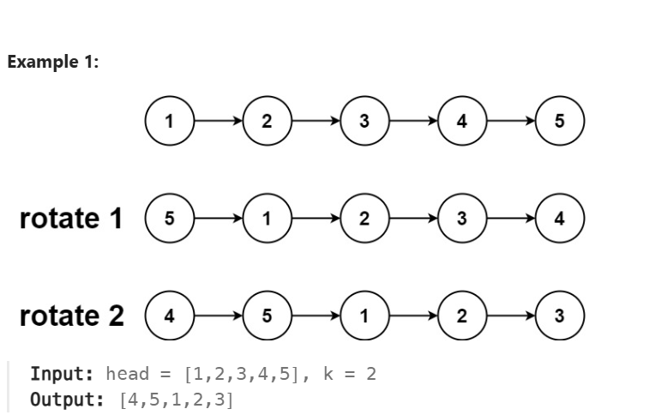
APP:
->find the length of the list and then rotate
->make it look like a circular one and traverse till (l-k)
->and then break the list it will point correctly
CODE:
class Solution {
public ListNode rotateRight(ListNode head, int k) {
if(head==null ||k==0 || head.next ==null)
return head;
ListNode temp = head;
int l = 1;
while(temp.next!=null)
{
l++;
temp = temp.next;
}
k = k%l;
if(k==0)
return head;
temp.next = head;//temporarily changed to dll like

ListNode res = head;
for (int i = 1; i < l - k; i++)
{
res = res.next;
}
ListNode fin = res.next;
res.next = null;
return fin;
}
}

LC#143 REORDER LIST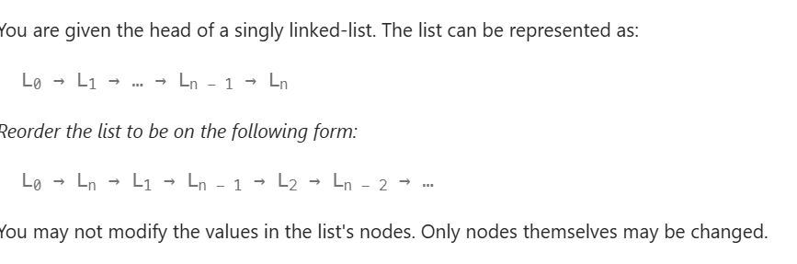

APP:
->use fast and slow app to find the middle of the linked list
->reverse the second half
-> link alternatively
class Solution {
public void reorderList(ListNode head) {
if(head==null && head.next==null)
return;
ListNode slow = head;
ListNode fast = head;
while(fast!=null && fast.next!=null)
{
slow = slow.next;
fast = fast.next.next;
}
ListNode curr = slow.next;//middle of list
slow.next = null;//breaking
ListNode sec = revNode(curr);//second half reversed
ListNode first = head;

while(sec!=null)
{
ListNode t1 = first.next;
ListNode t2 = sec.next;
first.next = sec;
sec.next = t1;

first = t1;
sec = t2;
}

}
ListNode revNode(ListNode head)
{
ListNode prev = null;
ListNode curr = head;
while(curr!=null)
{
ListNode nn = curr.next;
curr.next = prev;
prev = curr;
curr = nn;
}
return prev;
}
}

LC#328 ODD EVEN LINKED LIST
Given the head of a singly linked list, group all the nodes with odd indices together followed by the nodes with even indices, and return the reordered list.
The first node is considered odd, and the second node is even, and so on.
Note that the relative order inside both the even and odd groups should remain as it was in the input.
You must solve the problem in O(1) extra space complexity and O(n) time complexity.

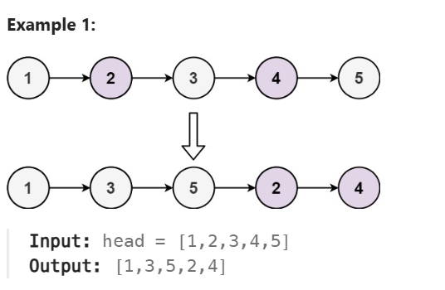
APP1:
->copy the elements into an arraylist and then assign it to the list
->TC:O(N) , SC(O(N)❌
class Solution {
public ListNode oddEvenList(ListNode head) {
if(head==null || head.next==null)
return head;
ArrayList<Integer> res = new ArrayList();
ListNode temp = head;
while(temp!=null && temp.next!=null)
{
res.add(temp.val);
temp = temp.next.next;
}
if(temp!=null)
res.add(temp.val);
temp = head.next;
while(temp!=null && temp.next!=null)
{
res.add(temp.val);
temp = temp.next.next;
}
if(temp!=null)
res.add(temp.val);
temp = head;
int i = 0;
while(temp!=null)
{
temp.val = res.get(i);
i++;
temp = temp.next;
}
return head;

}
}

APP2:
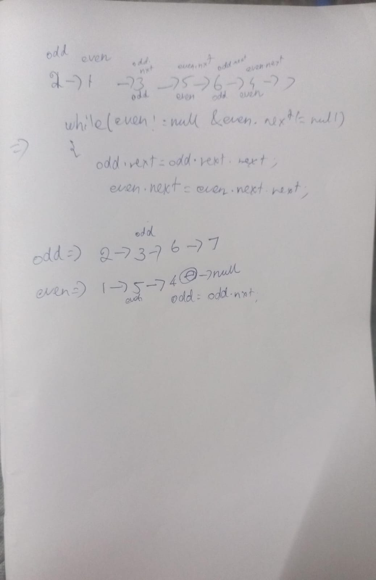

->simply traverse odd and even 2 steps finally link the odd to the even list
->here firstly we are updating the next of the odd and even
-> after the updation moving one point makes it move two points in the real head since we have altered the odd.next and even.next respectively so no issues
-> lastly connect the end of the odd to the even list and return
->TC:O(N) , SC:O(1)
class Solution {
public ListNode oddEvenList(ListNode head) {
if(head==null || head.next==null)
return head;
ListNode odd = head;
ListNode even = head.next , evenHead = head.next;
while(even!=null && even.next!=null )
{
odd.next = odd.next.next;
even.next = even.next.next;
odd = odd.next;
even = even.next;
}
odd.next = evenHead;
return head;

}
}

LC#86 PARTITION LIST
Given the head of a linked list and a value x, partition it such that all nodes less than x come before nodes greater than or equal to x.
You should preserve the original relative order of the nodes in each of the two partitions.
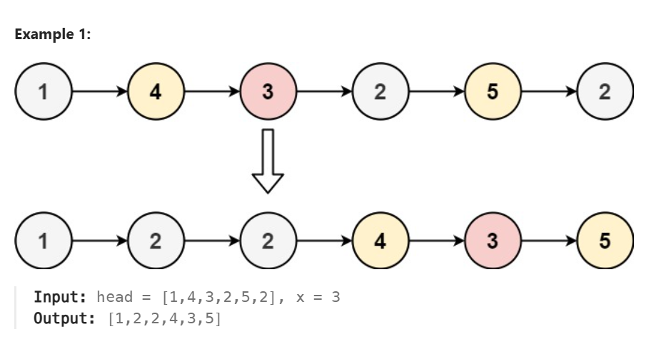

APP:
->create two nodes and store the starting point also
-> if it less than the value , add it to the left node , otherwise add it to the greater node
->finally greater.next = null for breaking the chain otherwise no end
->link the left to the g(starting point of greater)
->return the l(starting point of less)
class Solution {
public ListNode partition(ListNode head, int x) {
ListNode l = new ListNode(0);
ListNode g = new ListNode(0);
ListNode less = l , greater = g;
while(head!=null)
{
if(head.val<x)
{
less.next = head;
less = less.next;
}
else
{
greater.next = head;
greater = greater.next;
}
head = head.next;
}
greater.next = null;//ending the last
less.next = g.next; // create ref node for beginning identification
return l.next;//ref node for beginning

}
}

